

Application Pack
Church Manager

Contents
About Christ Church – page 2
Job Description – page 4
Person Specification – page 7
Application Form – page 8
Vision & Mission – page 13

Key Dates
Applications close at 12noon on 17 March 2026
Shortlisted applicants will be invited to be interviewed in person on 25 March 2026

Contact
For an informal chat or to submit your application please email the vicar
Revd Ben Green ben@rev.uk

About Christ Church Selly Park

Who we are
We are a friendly, evangelical family church that is passionate about joining in with God’s mission of making (new), growing (as) and sending (out) disciples of Jesus. We have a membership of around 200 children, young people and adults, with four members of part-time staff plus our vicar. God has blessed us in recent years as we start to see fruit from our engagement with our community, and as we have invested in youth and young adults – including seeing new Christians and people exploring faith. We have a particular gift for hospitality, but are not always good at making the most of the opportunities that gives us for sharing the gospel – so we would love you to join us!

Ministries
We encourage one another to serve Jesus when we are scattered during the week, through friendships and networks, informal mentoring etc. We have Life Groups that meet (mostly weekly) for fellowship, Bible study and prayer, comprising around 80-90 of our members. We gather in a modern building that matches our informal style, and is used heavily during the week – by us and other groups. We are a busy church – which is not always a good thing, but reflects our heart to engage with our parish:
- Young Adults: Bible study (1st and 3rd Sunday evenings), lunch with social / games (2nd Sundays) and with the whole church (4th Sundays), and ad-hoc socials (5th Sundays)
- Toddlers on Monday & Thursday mornings during term time
- Afternoon Fellowship on every other Monday
- Bereavement Support Group on Tuesday mornings
- Warm Welcome on Tuesday lunchtimes (all year) and Friday evenings (winter only)
- Lunch Club on Wednesday lunchtimes
- Renew (youth group) on Wednesday evenings (to focus on building relationships / social – we also meet on Sundays during the service for Bible study and discipleship)
- Church-sponsored Scouting groups on Thursday evenings during term time, plus Guiding groups on Monday evenings during term-time
- Coffee Mates on Friday mornings during term time
- Various prayer meetings on a weekly / monthly / bi-monthly basis
- And many other groups and teams that support our shared life and ministry

Sundays
On Sundays we sing modern songs and hymns, and our services are centred on the reading, preaching and faithful proclamation of the Word, often working our way through a book of the Bible (recent series include ‘Revelation: the Lamb Wins’, ‘The Heart of Hospitality’ and ‘John: Life in Jesus’ Name’). We offer prayer ministry after the morning service, and refreshments.
Once a month we have an Explore service where as a family we ‘Explore the Bible Together’ in a variety of styles, e.g. zones around the building, café-style around tables, etc. We also have a Praise & Pray gathering once a month on Sunday evenings, aiming to be ‘Charismatic, open, joyful, spontaneous, flexible’, and a quiet service twice a month early on Sunday mornings. We share lunch after the communion service on the 4th Sunday of every month.

Our history
Christ Church started life as the ‘Church Centre’ of St Stephen’s Selly Park. It grew as a congregation particularly through its ministry to families and toddlers, to the point where it became a church in its own right in the early 2000s.
The old building was torn down, rebuilt and opened in 2009. The flexible space is in so much demand on weekday evenings we’ve had to embargo bookings on a Tuesday evening, simply so we can use it ourselves!
There is significant deprivation in our parish (https://cuf.org.uk/parish/520212). Opposite our building are a number of HMOs (Houses of Multiple Occupancy) and a largely transient population, which can make it difficult to build relationships. Starting Warm Welcome during the Cost of Living Crisis was a significant moment in connecting with some of those that we have historically struggled to meet.

Job Description
Church Manager

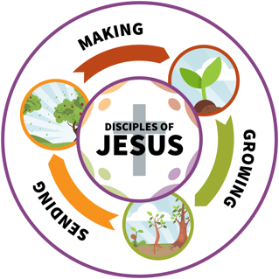
Summary
Location: Church Office, Christ Church Selly Park, B29 7PS
Responsible to: The Vicar
Start date: Spring 2026

Key Objectives
As Church Manager you will provide passionate and experienced leadership, supporting and releasing our volunteers, staff and Vicar to serve God faithfully in our parish and beyond – in line with our vision and mission.
You will work closely with the Vicar, overseeing our day-to-day activities and ad-hoc projects, ensuring efficiency, compliance and a high standard of execution and excellence.
You will navigate the intricacies of church life with the right balance of high capacity and execution, exceptional communication and troubleshooting, influencing and diplomacy. You will be the primary contact for the staff team for operational issues, and bring leadership to key areas such as scheduling, Sundays and project management.

Key Areas of Responsibility

Operations
- Working closely with the vicar to build and maintain a strong and healthy culture in line with our vision and mission.
- Being the primary point of contact for staff team on troubleshooting, information and negotiating solutions between ministries; escalating where strategic or structural decisions are required by the Vicar or PCC.
- Leading the Ops Team (staff plus volunteers).
- Contributing to key meetings throughout the church as required (e.g. APCM).
- Responsibility for the management of various projects under the direction of the Vicar, whether coordinating of major events in the life of the church, implementing of new systems or working closely with volunteers and professionals on gatherings or events.
- Ensuring all church events are smoothly executed and well-planned.
- Ensuring resources (buildings, staff time, volunteers, equipment) are strategically allocated effectively to meet priorities.
- Managing the effective and efficient operation of the church offices and other administrative resources, to ensure the environment is conducive for staff and volunteers to carry out their job effectively.

Staff
- With the Vicar, leading staff appraisals including reviewing job descriptions and contracts.
- Line management of cleaner and caretaker, and other staff as agreed with the Vicar.
- Day-to-day HR management (e.g. annual leave, sick leave and cover).

Communication
- Working closely with the Vicar and Ops Team to ensure all church communications (including weekly newsletters, term cards, website, publicity, signage) are accurate and consistent.
- Ensuring rotas, events and bookings are created, communicated well and kept up-to-date.

Site / Building
- Chairing Site Committee meetings and ensuring minutes are taken and circulated.
- Overseeing the smooth running of facilities and contracts to ensure their effective use in terms of both ministry and income.
- Building relationships with regular / major hirers as account manager.
- Purchasing stock / resources / equipment as a church debit card holder.
- Invoicing for (e.g.) bookings, occasional offices.
- Assisting the Vicar and Wardens in applying for faculties and other necessary permissions.

Safeguarding
- Working with the Parish Safeguarding Officer and Vicar to ensure best-practice in culture, recruitment, record-keeping and reporting across the church and all ministries.
- Chairing the Safer Recruitment Team; ensuring safer recruitment practices are in line with Church of England requirements (and recommendations where possible).
- Assisting Parish Safeguarding Officer as a DBS ID verifier and in managing the Safeguarding Hub, Safer Recruitment database and Action Plan.

Finance
- Working with the Treasurer and Vicar and by use of our bookkeeping software ExpensePlus, to ensure that financial management processes are followed, expenditure is managed and monitored, and keeping budget holders accountable.
- Supporting grant applications and project bids as required.
- Completing quarterly DBF returns.
- Overseeing petty cash for church groups and banking of cash.

Compliance
- Ensuring HR and risk management procedures are in place and effective compliance for the organisation.
- Taking responsibility for the data protection strategy, ensuring all staff are compliant with GDPR, and other applicable data protection laws, and that the organisation holds up-to-date Data Protection and Privacy Policies and complies with required reporting.
- Reporting as required (e.g. statistics for mission, grant compliance).

Other ad-hoc projects and support as required and agreed with the Vicar.

Terms
Church membership: we expect the candidate to be or become a worshipping member of our church
Hours: 25 hours per week with an expectation to work flexibly including some evenings and weekends (with TOIL provided where required)
Contract: permanent, subject to a 6-month probation period
Salary: £17.92 per hour / £23,300 per annum (pro-rata equivalent to the National Stipend Benchmark) plus a pension contribution of 3%
Holiday: 20 days per annum plus bank holidays (pro-rata ~ 18.7 days in total), plus the day after Boxing Day until New Year’s Eve inclusive for office closure
Retreat: up to three days for personal retreat across the year
Expenses: those incurred in exercising the role will be reimbursed by the PCC, after prior agreement with the Vicar and treasurer
The PCC of Christ Church Selly Park believes it is a genuine occupational requirement that the person appointed is a committed practising Christian. The Employment Equality (Religion and Belief) Regulations 2003 Section 7.2 applies.
The PCC of Christ Church Selly Park is committed to safeguarding and promoting the welfare of children, young people and vulnerable adults. All post holders and volunteers are expected to share this commitment. All appointments are subject to acceptable pre-appointment checks, including a satisfactory Enhanced DBS Check.

Person Specification
- A committed, practising evangelical Christian from a Christian Trinitarian denomination who puts Jesus at the centre of his / her life and ministry, and the Bible at the centre of his / her faith and understanding of God
- A servant heart and a teachable spirit
- Strong leadership and management skills
- Strong communication skills
- Highly motivated and able to take initiative
- Effective negotiating and influencing skills
- Highly competent in computer/IT skills, including experience in ChurchSuite or Microsoft, or the ability to adapt to new technologies
- Good commercial understanding and experience
- Maintaining confidentiality on highly sensitive matters
- Proactive and self-motivated
- An ability to juggle a broad range of responsibilities
- Ability to relate to a wide range of different people in different roles including clergy, staff, volunteers and community partners
- Initiative to seek solutions and implement new ways of working
- Excellent time management skills with proven ability to prioritise workload
- Excellent organisational and administrative skills
- Ability to work well under pressure, cope with frequent change and meet deadlines
- Demonstrates a strong understanding of cultural awareness

Application Form
The boxes will expand as you type – but please be concise
(apart from 5(b) answers should be no more than 250 words).
If you require a printed version of this form, please contact us.

1. Personal Information
Full Name
Address (UK only)
Mobile
Email

2. Education & Qualifications

(a) Please list in reverse date order (starting with most recent):
Date | Establishment / Qualification

(b) Other relevant training, professional qualifications or work-related skills:

3. Employment & Other Responsibilities

Please list in reverse date order (starting with most recent) a summary of church and secular employment and any relevant voluntary work (with dates).
Date | Employment / Role / Responsibility

4. Experience & Skills

(a) Why are you applying for this post?

(b) What spiritual gifts, skills and experience do you believe you possess that will make you suitable for the role?

(c) What personal qualities do you believe you have which would contribute to a church staff team?

(d) Do you have any other interests / achievements / responsibilities that you think are relevant to share with the selection panel?

5. Vision

(a) Describe the place and role of administration in the life of a church.

(b) Describe your vision for this post, highlighting the most important elements.

6. Faith

(a) Please state briefly what you believe about the Bible and its place in the Christian life.

(b) Please state briefly what you believe about the death, resurrection and ascension of Jesus Christ and the importance of these events for the Christian.

(c) Please state briefly what you believe about the person and work of the Holy Spirit.

7. Your Circumstances
Do you currently have the right to work in the UK? YES / NO
Do you require special access for the purposes of an interview? YES / NO
If yes, please describe any special conditions or adjustments required:
Do you have a full driving licence? YES / NO
Do you have any current endorsements? YES / NO
If yes, please give details:
Do you have access to a car you are able to use for work purposes? YES / NO
Have you ever been convicted of a criminal oﬀence, other than a spent conviction under the Rehabilitation of Oﬀenders Act 1974? YES / NO
If yes, please supply further details on a separate sheet.
Note: This post is subject to a satisfactory DBS check.

8. Personal Information
Personal information from this application may be processed by the Employer under the General Data Protection Regulation (GDPR). Please see our Privacy Notice on our website for full details.
I hereby give my consent to the organisation processing the data supplied in this application form for the purpose of recruitment and selection.
I declare that the information given in this application is to the best of my knowledge complete and correct. I authorise the organisation to check on any of my qualifications.

Signature _______________________________________ Date ________________

Print Name _______________________________________

Note: Any false, incomplete or misleading statements may lead to dismissal.

9. References
Please supply the names and addresses of three referees who know you well, but who are not related to you. One should be from your minister or church leader. If you currently hold a job, one should be from your manager or equivalent at that place of work. (Please indicate if taking up this reference before interview will cause you any problems.)

Referee 1
Title
Name
Address
Phone / Mobile
Email
How does this referee know you?

Referee 2
Title
Name
Address
Phone / Mobile
Email
How does this referee know you?

Referee 3
Title
Name
Address
Phone / Mobile
Email
How does this referee know you?

Vision & Mission
The full document – with supporting Bible verses – is available on our website https://christchurchb29.org/resources/vision-mission/

Our Vision
We long to see: God’s name honoured, his kingdom come, lives transformed

Our Mission
Who we are: God sent his Son to buy freedom for us, so that he could adopt us as his very own children. And because we are his children, God has sent the Spirit of his Son into our hearts.
What we do: Jesus said, ‘Go and make disciples of all nations, baptising them and teaching them to obey everything I have commanded you. And surely I am with you always, to the very end of the age.’
Our mission is to join in with our Father’s mission by: making, growing, sending disciples of Jesus
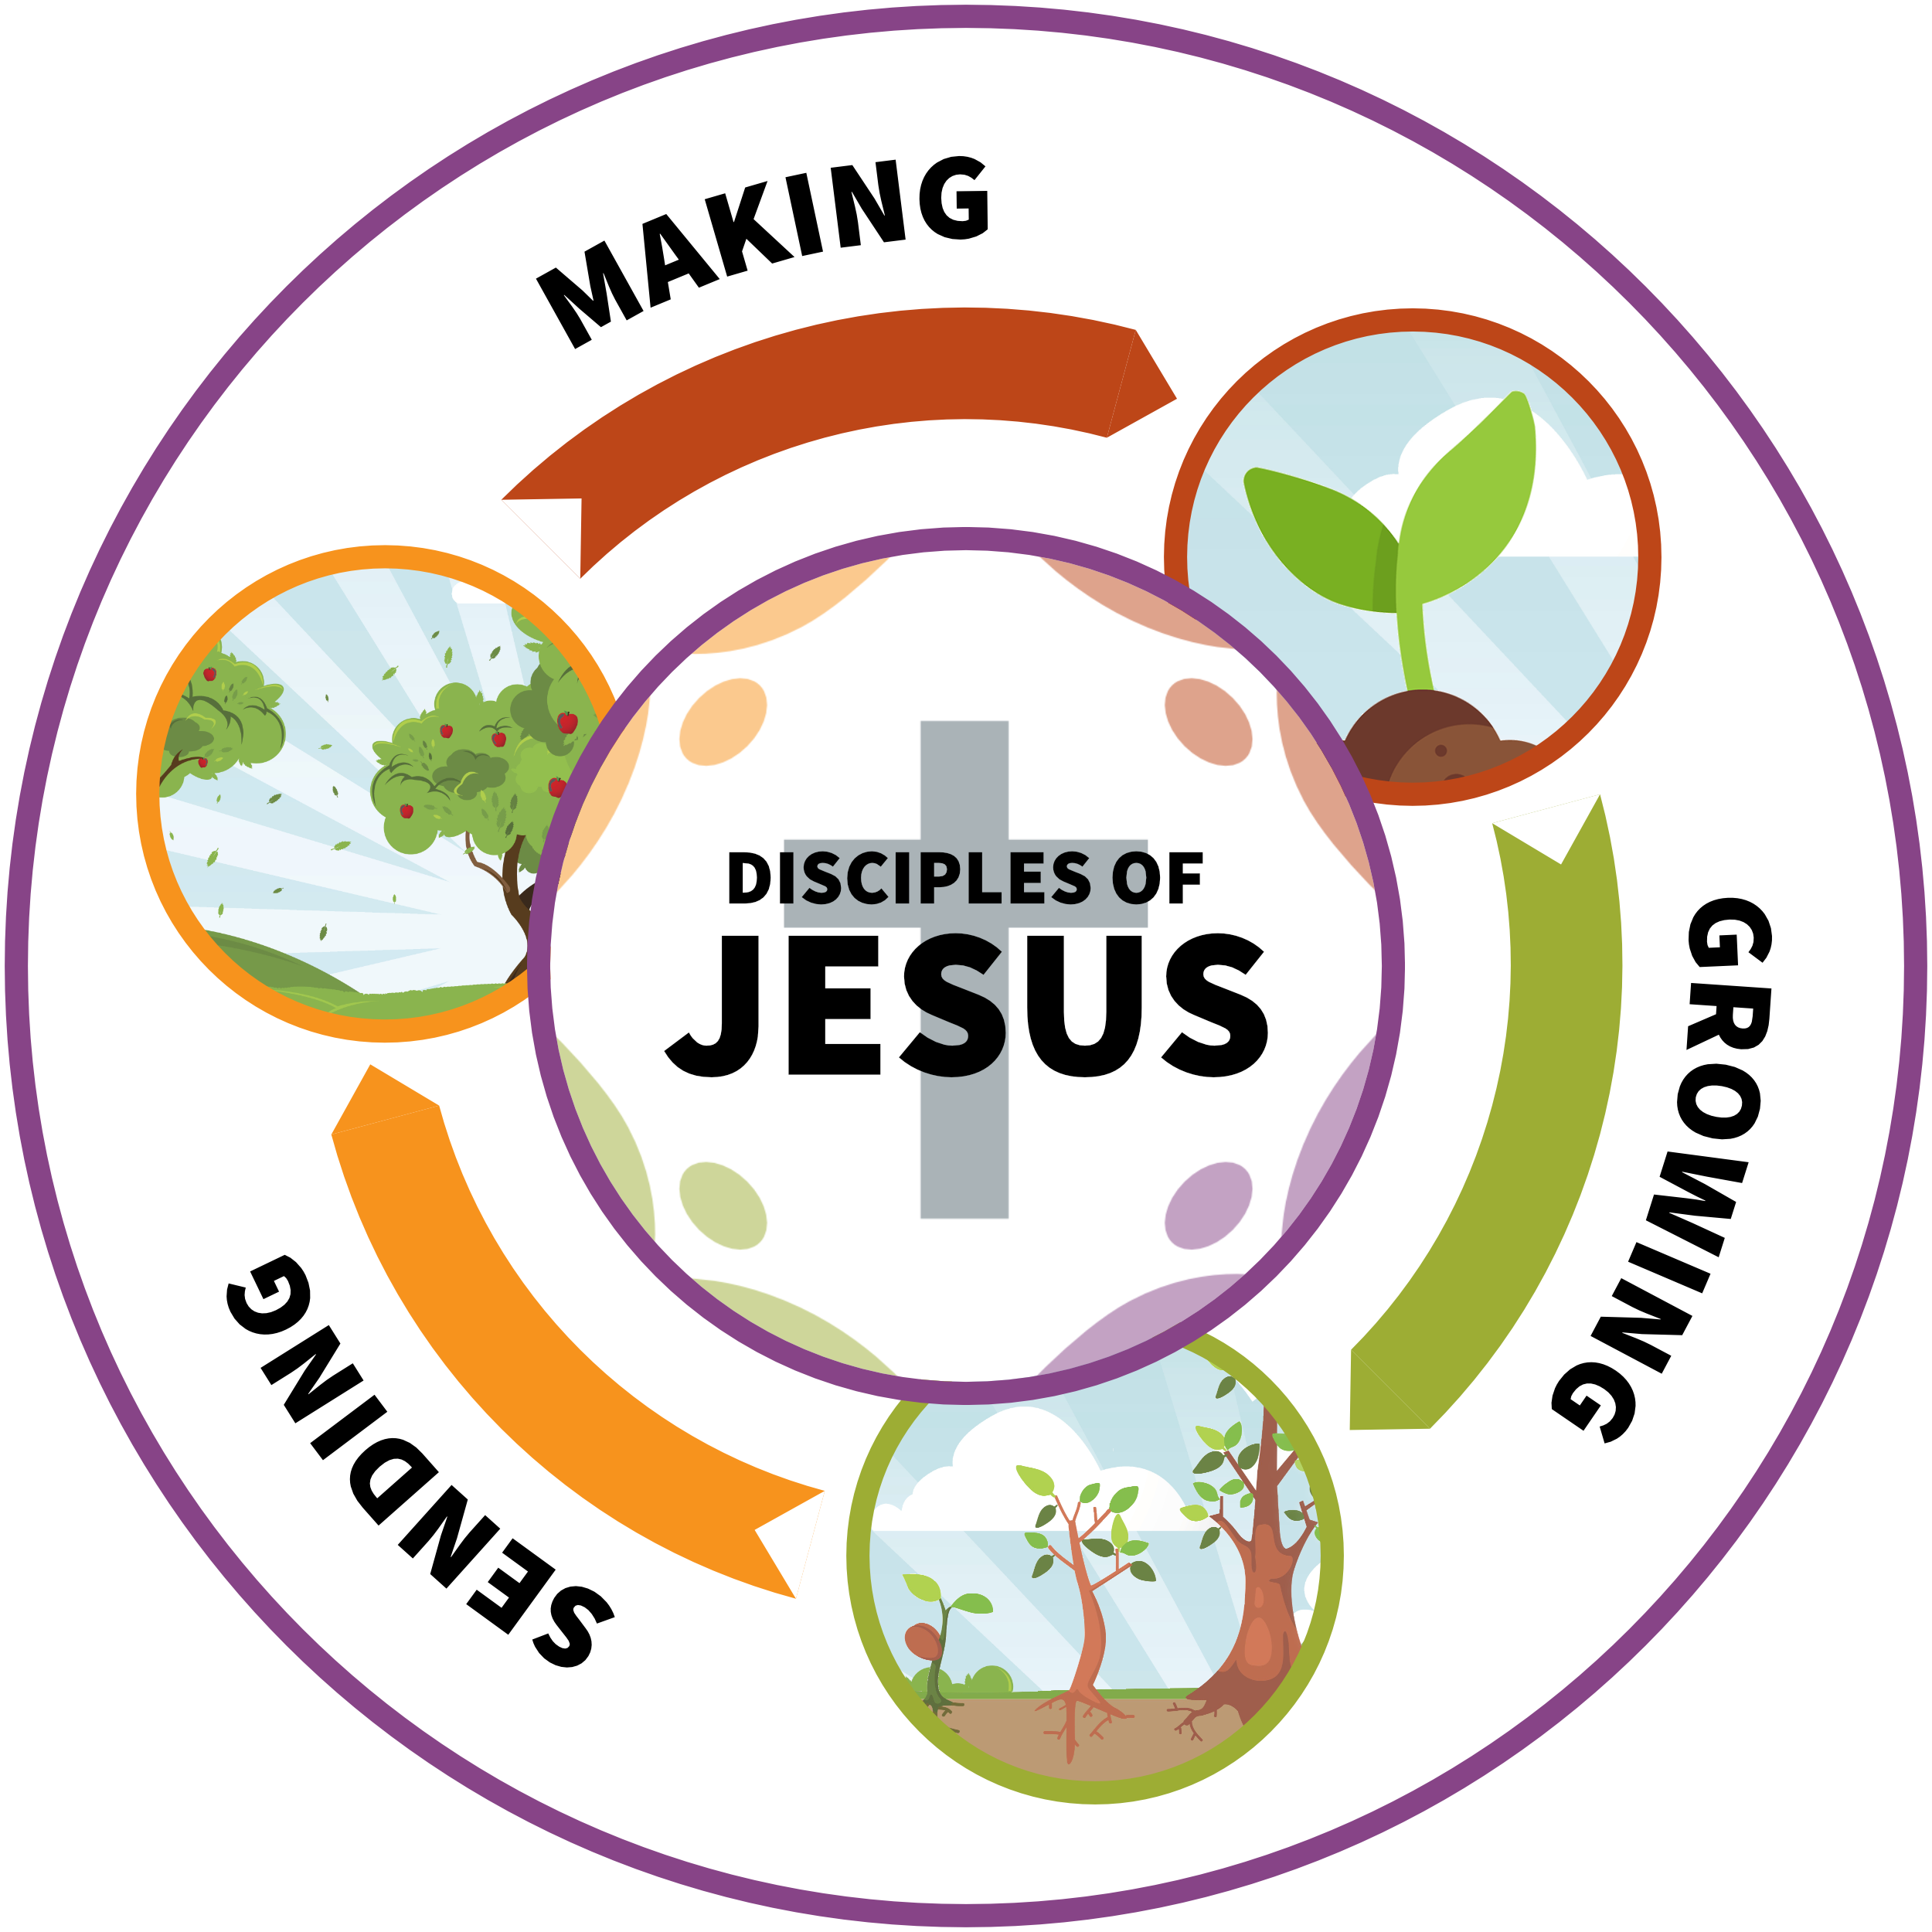
MAKING new disciples of Jesus means
we all share what God calls us to share:
good news that through Jesus everyone can be forgiven, adopted as children into God’s family, and receive new life in his kingdom
GROWING as disciples of Jesus means
we all live as God calls us to live:
as God’s holy people, filled with his Spirit, built up in love and unity – becoming who we are more fully, to please God
SENDING out disciples of Jesus means
we all go wherever God calls us to go:
into all the world as salt and light – to our friends and families, neighbours, workplaces and beyond – in love and self-sacrifice


MAKING – how?
Sharing Jesus in word and deed with confidence and grace
Inviting others to come and see Jesus for themselves
Praying for people to turn to Jesus and receive his life

GROWING – how?
Serving the Lord our Father and one another in love every day
Listening to Jesus through the Bible with faith and obedience
Walking in the power, fruit, gifts and ministries of the Spirit

SENDING – how?
Following Jesus with courage, trusting he is with us
Going and being a blessing to all peoples and all creation
Standing Firm against evil and darkness in the name of Jesus

This is our worship: our whole lives transformed and renewed by God, lived for his praise and glory

Our Prayer
This is our prayer: Come Holy Spirit – be poured out on us, fill us, and make us new

See page 13 for full details.

